Happy Holidays!

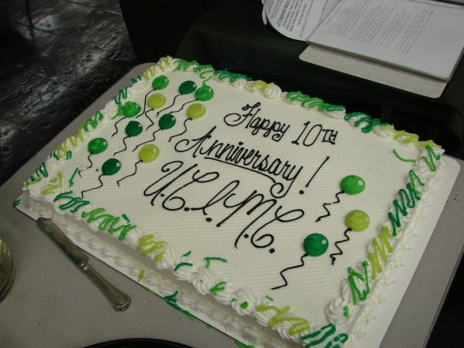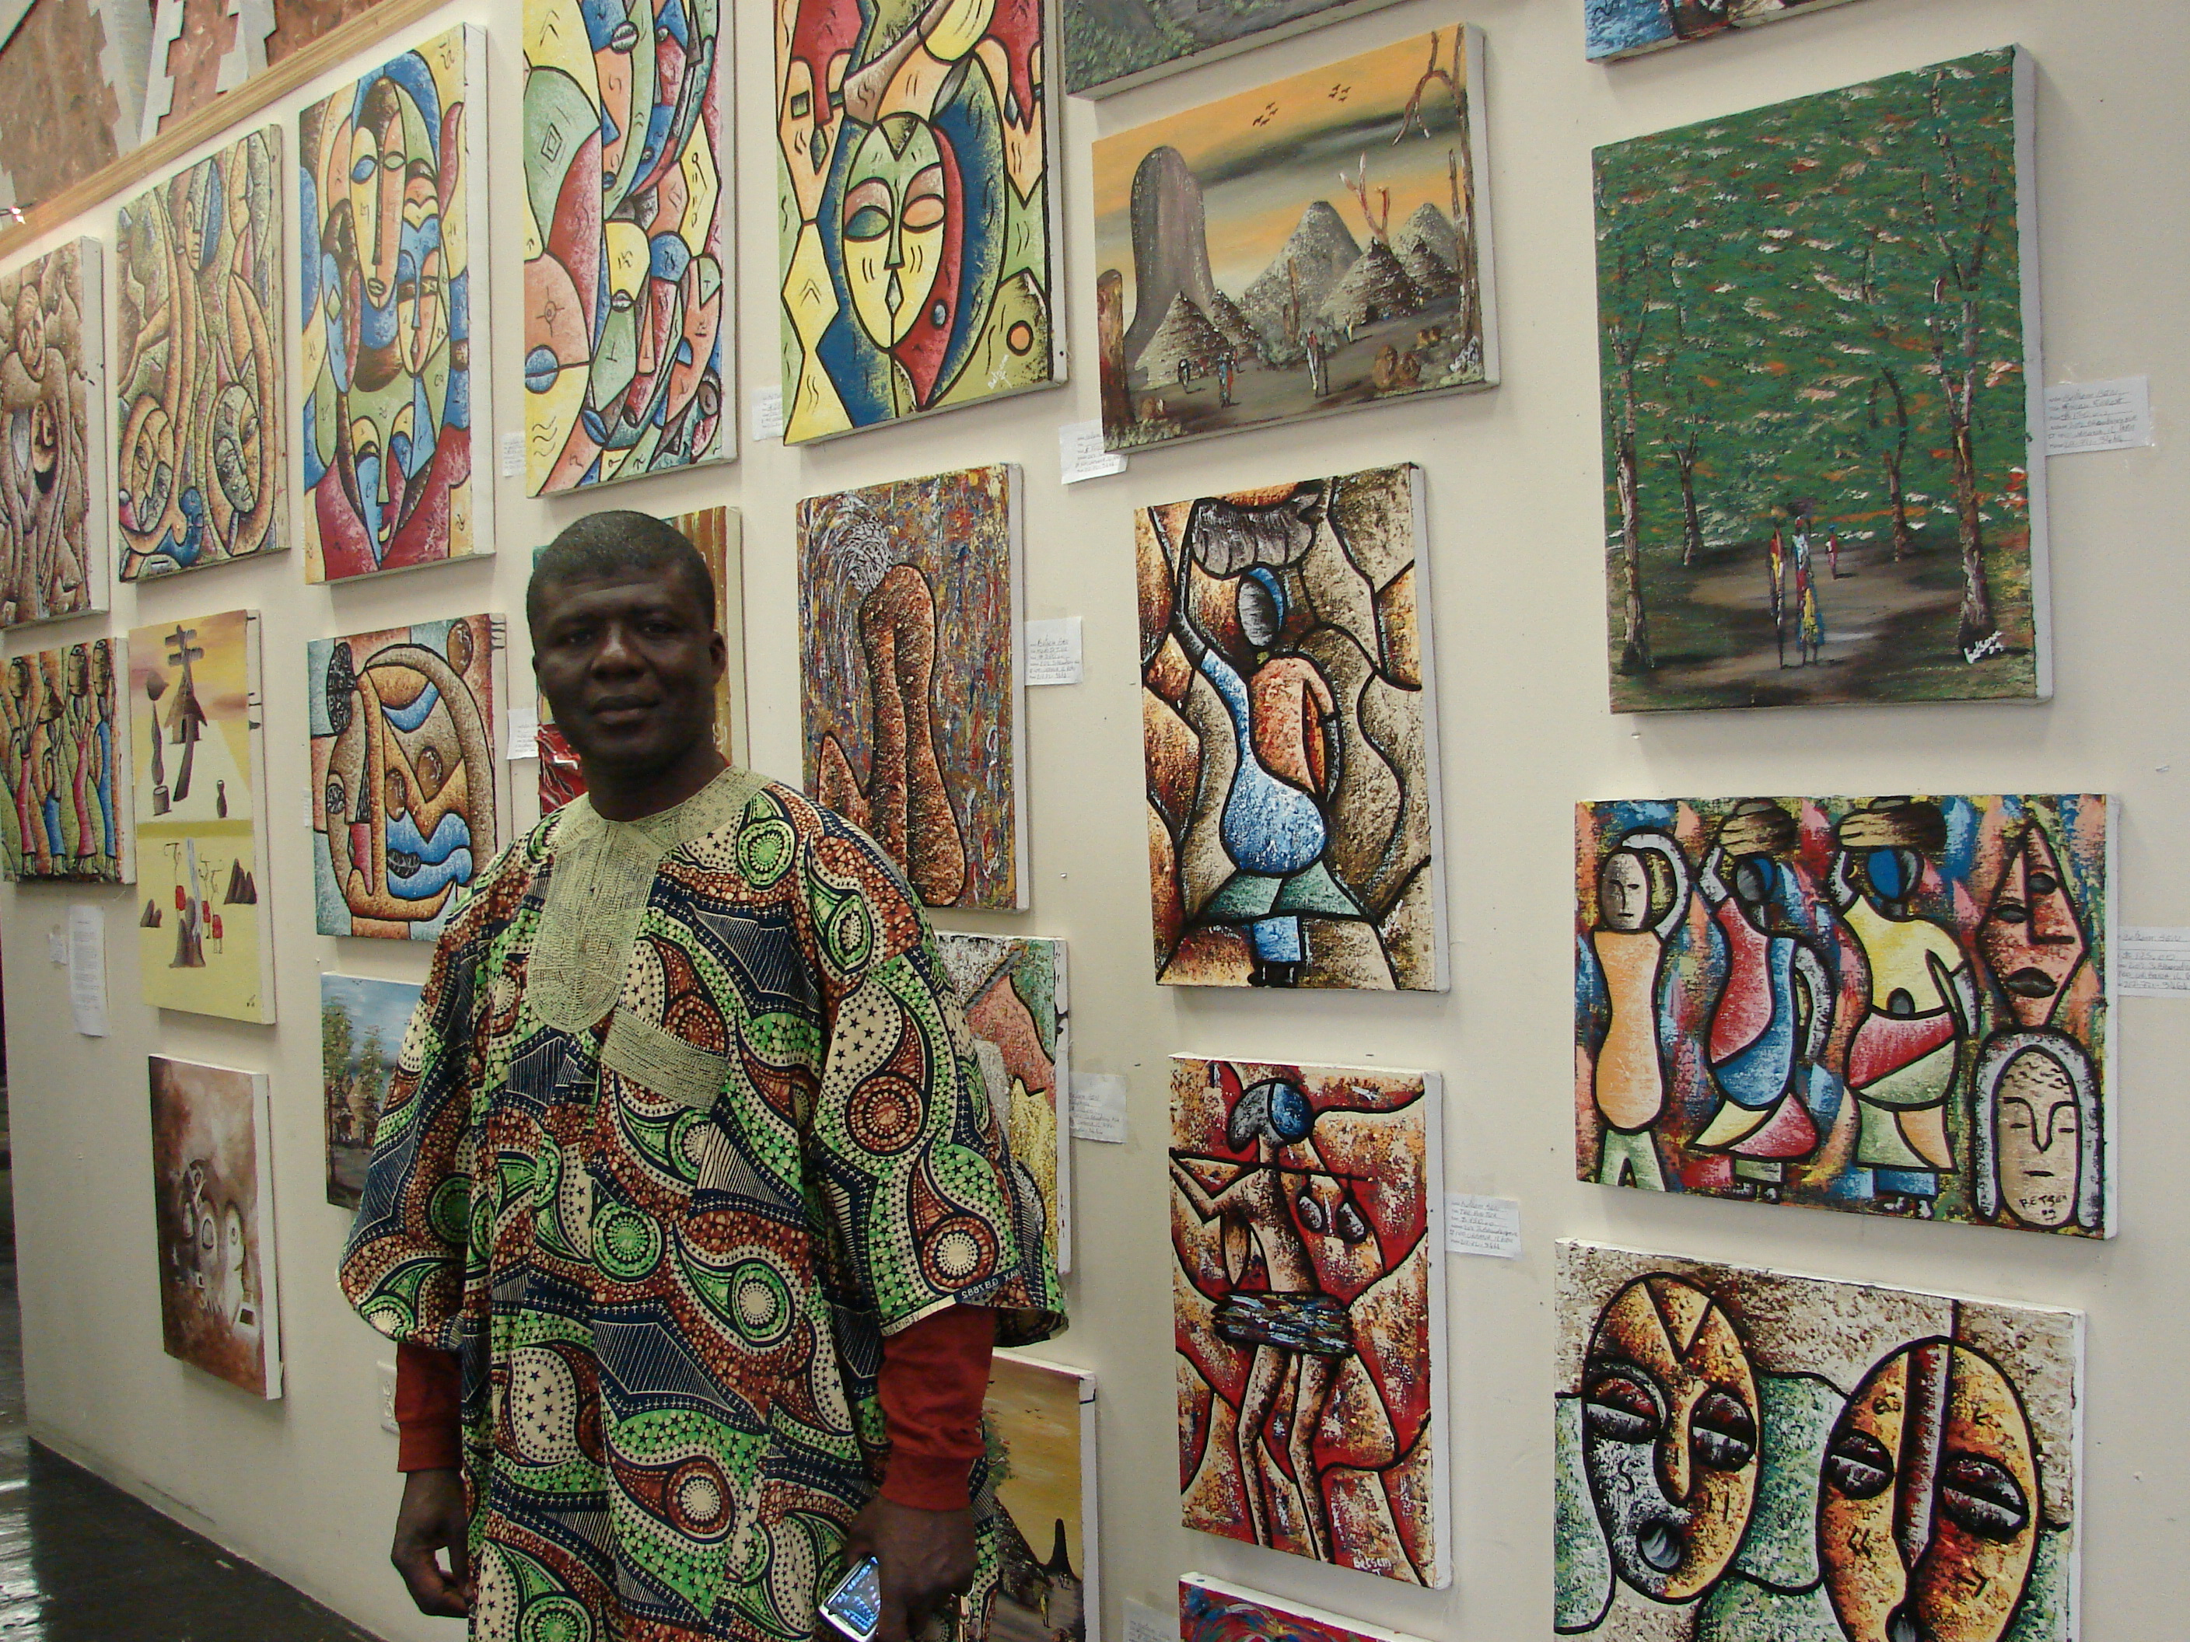
This year, the Urbana-Champaign Independent Media Center celebrated its 10th Anniversary with another year of unparalleled growth & success. We’re still glowing from our successes this year, including WRFU’s 5th Anniversary, the 2nd IMC Film Fest, the singular Childrens Art Fest, our ever-growing IndyMedia & Arts Lab … the list goes on and on!

We’re particularly excited about the new IMC Help Desk, a free service where community members can bring in computers or questions, get a free diagnosis or recommendation, and learn invaluable computer troubleshooting skills by participating in the repair process. The Help Desk, founded this year, has already served over 150 community members.

2011 will be a landmark year for the UC-IMC. We have a number of innovative collaborations in the works, and each of our groups is strengthening its work. Supporting our ever-improving programming is the new Sustainers Fund, which is helping us pay down the mortgage, creates an Emergency Fund, and ensures our financial stability.
I hope that you’ll consider supporting the UC-IMC with a donation this year. You can easily pay online or write us a check!
To everyone who supported our work this year through donations, volunteer hours, creative input, or any other way, we owe you a great big thank you! Have a great holiday & see you next year!
Warm regards, 
Austin McCann, Development Adviser
Urbana-Champaign Independent Media Center

